Fitness, Conditioning, Rhythem and Games
Clayton Middle School
Ms. Spiegel

Phone: 801-481-4810 school
Spiegel prep: 2nd period voice mail: ex. 1080

This class is designed to improve students overall health and fitness. Students will increase their knowledge of the F.I.T.T. formula and the 5 principals of fitness. Students will be responsible for setting and achieving specific fitness goals as well as designing their own effective, safe fitness program. Several different forms of exercise modalities, techniques, media, options and equipment will be used in order to provide students with a wide variety of lifelong fitness options. This is a great class for anyone who enjoys working out, wants to increase their overall fitness level or improve their performance in a specific sport.

GOALS: -100% participation -- 100% suited -- 100% work turned in.
-Greater knowledge of health, fitness and your body.
-Greater confidence in your athletic abilities.
-Develop a desire for lifetime physical activity.
-Experience the benefits of a continuous, structured, personal fitness program
Course
Materials: P.E. Uniform is required. Should be taken home at the end of each week to be washed!
White T-shirt with student’s first and last name across the chest. The printing of the name should be 2 inches high and done with a rub-a-dub marker. Solid colored athletic shorts: red, white, silver or light grey, with no belts, zippers or pockets. Athletic shoes with non-marking soles are required. No hiking shoes, sandals, or open heel shoes. All shoes must be laced up snugly. Non hooded sweatshirts should be kept in your gym locker for cooler weather…If it is not snowing or raining we will be going outside! We would like to encourage the students to purchase the school P.E. Uniform. 2 pocket folder, pen or pencil are also required.

Format: Fitness and Conditioning is an activity class; most of the days will involve movement and activities. There will also be lectures and written assignments.

GRADING: -Regular and complete dressing for P.E. -- 30%
-Participation and Involvement -- 40%
-Written work and assignments -- 30%

DRESSING POINTS: Proper suiting for class is very important. A student can not participate to the best
Of their ability if they are not wearing appropriate clothing. 100 pts for dressing each week

No Dress = 20 points 0 – 20 minus points = A
No Shirt = -10 points 21 – 30 minus points = B
No Shorts = -10 points 31 – 40 minus points = C
No Shoes = -10 points 41 – 50 minus points = D
Shoes only = -10 points 51 and up minus points =F
Dressing points will be calculated every week. If a student is not suited they lose both dressing and participation points for the day. You cannot participate to the best of your ability if you are not wearing appropriate workout attire.

PARTICIPATION:
- Be on time, dressed in P.E. uniform.
- Do all exercises, games and activities at 100% of your ability and with a positive attitude.
- Show good sportsmanship; help others in class and share leadership as well as follower responsibilities.
- Demonstrate improvement of abilities and skills during the term.
- Students with injuries or illness requiring more than two days of non-participation require a doctor’s note. Parent’s notes are often helpful, but don’t excuse a student from participation without an effect on their grade.
-Behavior points (dots) will be given for inappropriate behaviors such as; class disruption, lack of or poor participation, unsportsmanlike conduct, misuse of equipment, gum, etc. Dots are not good!!
You want to avoid them!

ASSIGNMENTS:
-Tests, assignments and journal entries will be given in accordance with each unit taught.
-Will be designed to increase knowledge, understanding and skill of the sport or activity.
-There will be several homework assignments throughout the year.
-Late work will be accepted with consequences.

CITIZENSHIP:
-The citizenship grade will be based on tardiness, referrals and behavior points ([Please see above information). Due to the fact that this is a participation course, behavior points affect both your academic and citizenship grade.

Extra Credit: A student can make up a total of 30 points per term. Makeup work will be determined at the start of each unit. No makeup work will be accepted the last week of each term.

OTHER INFORMATION: Things to keep in your personal P.E. locker:
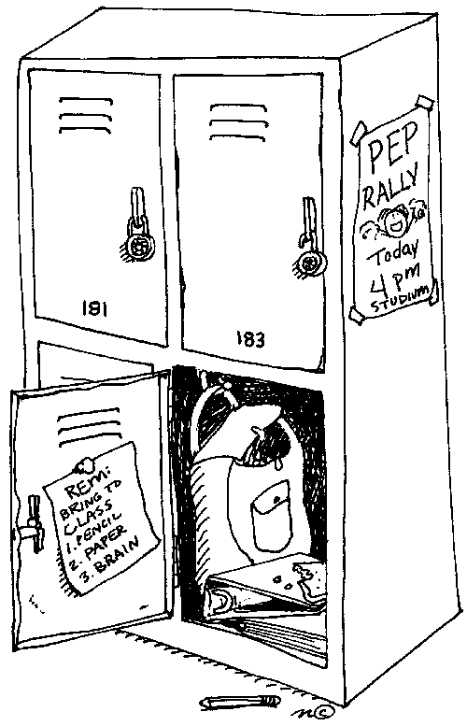
-P.E. uniform, deodorant, extra socks, athletic shoes, and wet wipes.
- We recommend a pair of athletic shoes that you did not wear to school.
-Absolutely no glass containers, powders, or aerosol cans!
-Absolutely no gum allowed.

IN THE LOCKER ROOM:
Absolute and total respect for others is the only acceptable behavior. No taunting, teasing, harassment, sexual harassment, vulgarity, or vandalism will be tolerated. Citizenship will be severely affected if this occurs. Infractions of this nature may also result in a safe school violation and a discipline by the District. If you feel that you are a victim of the above behaviors, let us know immediately. Absolutely no cell phones out or on in the locker room. We are not responsible for lost or stolen cell phones.

Respect for School environment property and equipment: You break it…You buy it. We understand that accidents happen and wear and tear is normal but blatant abuse and misuse will not be tolerated!

----------------------------------------------------------------------------------
I have read and understand the P.E. Disclosure
(Return just this lower portion to your P.E. Teacher; keep the disclosure in a safe place)

Students Name: _______________________________________________________(Please print full name neatly)

P.E. Period ___________ Teacher: Spiegel Parent Signature:________________________________________

The Salt Lake City School District does not discriminate on the basis of age, color, disability, national origin, pregnancy, race, religion, or sex.

